Signal generator and oscilloscope

1. Oscilloscope

|  |  |  |  |
| --- | --- | --- | --- |
| brand | model | details | price |
| Rigol | MSO5354 | BANDWIDTH: 350MHz  ANALOG CHANNELS: 4  REAL-TIME SAMPLE RATE: 8GSa/s  MAX. MEMORY DEPTH: 200Mpts(opt.)  WAVEFORM CAPTURE RATE: 500,000 wfms/s  DIGITAL CHANNELS: 16 | 28499RMB(we have) |

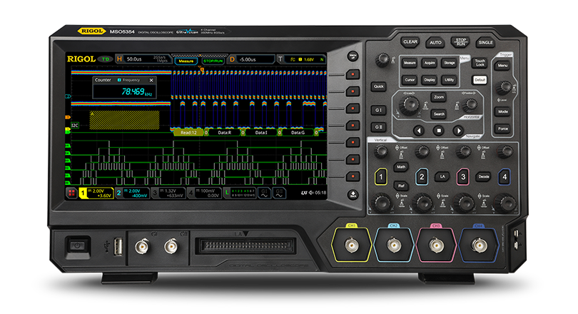

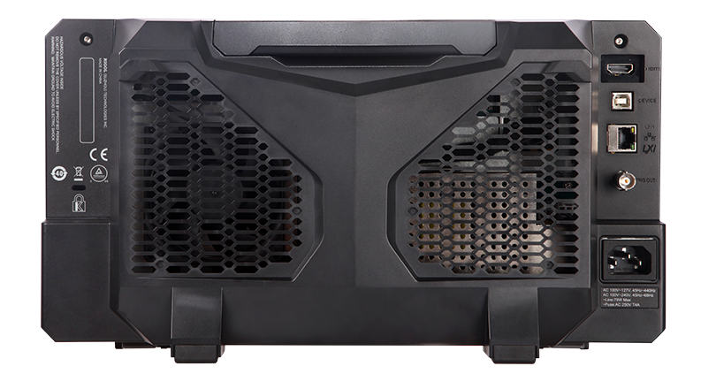

**Communication Interfaces: USB**

Need install Ultra Sigma first. Then determine the serial port number of the device and connect it, and send the SCPI command to the device through a string. What we need by MSO5354 is that，real-time acquisition of digital and analog signals of different channels, real-time drawing and save as a txt file in accordance with the format. If the file has two columns, the first column is the time and the second column is the analog. Each channel can be recorded individually.

1. signal generator

|  |  |  |  |
| --- | --- | --- | --- |
| brand | model | details | price |
| Rigol | DG1022Z | MAX. OUTPUT FREQUENCY: 25MHz  SAMPLE RATE: 200Msa/s  VERTICAL RESOLUTION: 14bit  CHANNELS: 2CH  ARBITRARY WAVE LENGTH: 2M(16M opt.) | ＄569 |

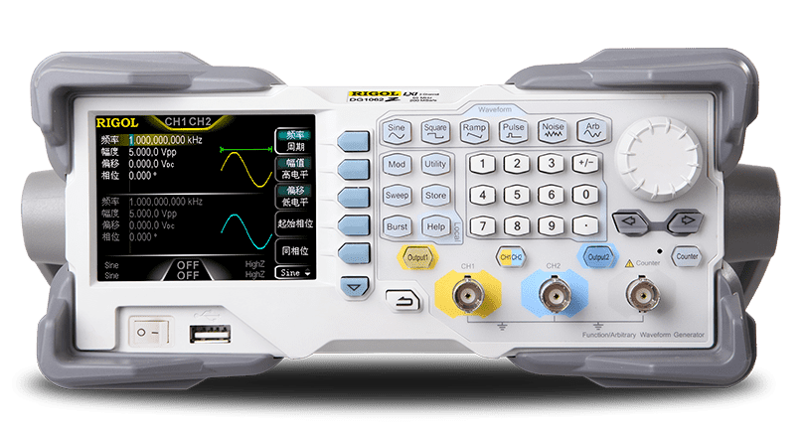

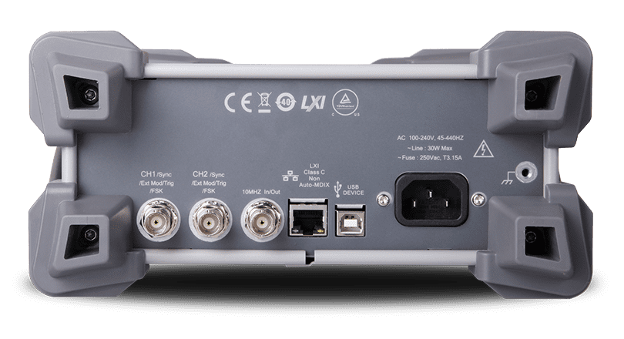

**Communication Interfaces: USB**

Computers communicate with the generator by sending and receiving commands over **USB interface**. Command is sended and identified in the form of **ASCII character strings** for users to easily control the generator and do user-defined development.

**Example：**Generate a user-defined arbitrary ramp wave with 10μs period, 4V high level and -4V low level.

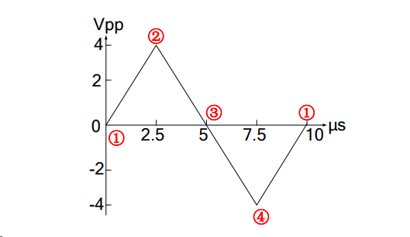

The vertical resolution of user-defined arbitrary wave is 14 bits, 0 and 16383 separately correspond to the minmum and maximum amplitudes, that is: -4 V corresponds to 0 and 4 V corresponds to 16383. So, edit the points in following table to generate the specified ramp wave.

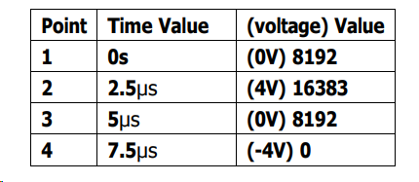

0 *IDN? /*Query ID to check the operating state */

1 FUNC USER /*Select user-defined arbitrary wave*/

2 FREQ 100000 /* Set the frequency as 100kHz (period: 10μs)*/

3 VOLT:UNIT VPP /* Set the unit of voltage*/

4 VOLT:HIGH 4 /* Set the high level*/

5 VOLTage:LOW -4 /*Set the low level*/

6 DATA:DAC VOLATILE,8192,16383,8192,0 /*Load the 4 decimal numbers to volatile memory */

7 FUNC:USER VOLATILE /*Output the waves in volatile memory */

8 OUTP ON /* Enable the [Output] connector of CH1 at the front panel */

*What we need, is to read a txt / CSV file to get the arbitrary waveform data，change the data in ***command 6*** and change the FREQ in ***command 2***.